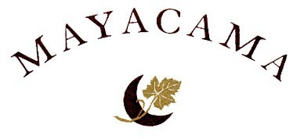

TOURNAMENT FORMAT: The tournament will be a 36-hole two-person team event. The format is “One Better-Ball of the Two Partners” using the Stableford Point System. Two players play as partners, each playing her own ball. The higher point total between the partners on each hole will be the score that counts. If one partner fails to complete the play of a hole, there is no penalty.

In the Stableford Point System, players receive points as follows:
- Net Double Bogey or Higher: 0 Points
- Net Bogey: 1 Point
- Net Par: 2 Points
- Net Birdie: 3 Points
- Net Eagle: 4 Points

TEAMS: Teams will be comprised of one Mayacama Member and one Guest.

FLIGHTS: The field will be divided into flights based on the combined course handicaps of the two partners. Each flight will consist of four teams.

OVERALL CHAMPION: The Overall Champion will be the Team which earns the most points out of the entire field.

HANDICAP INFORMATION: Members and Guests are required to have an established current U.S.G.A. Handicap Index in order to compete for prizes. Each player will receive 95% of her Course Handicap. The Maximum allowable Course Handicap is 36 Strokes. (Note: The maximum handicap differential between partners is 10 Strokes.)

PRIZES: Prizes will be awarded to each Flight Champion and Runner-Up.

PAIRINGS: Flights, Pairings, and Hole Assignments will be posted in the Golf Shop on Sunday, August 31, 2008. Teams will be paired within their respective flight (two nine-hole pairings on Thursday and one eighteen-hole pairing on Friday).

TEES: All competitors shall play from the Forward Tee Markers.

SPECIAL CONTESTS: There will be closest to the hole contests on all par three holes for members and guests.

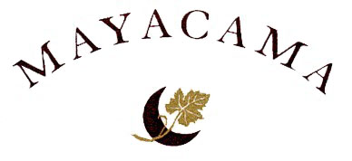

2008 WOMEN’S MEMBER-GUEST
SCHEDULE OF EVENTS

WEDNESDAY – SEPTEMBER 3

7:30 a.m. – 1:00 p.m.
Practice Round
Please call the Golf Shop to schedule your practice round

12:30 – 6:00 p.m.
Early Registration in the Clubhouse Lobby

6:00 – 8:00 p.m.
Welcome Reception and Heavy Hors D’oeuvres

THURSDAY – SEPTEMBER 4

7:30 – 10:00 a.m.
Registration in The Clubhouse Lobby
9:00 – 10:00 a.m.
Welcome Brunch
10:30 a.m.
Shotgun Start – First 9-Holes
1:00 p.m.
Players Lunch
2:00 p.m.
Shotgun Start – Second 9-holes

4:30 – 7:30 p.m.
Evening Festivities include Cocktails and Hors D’oeuvres
Putting and Closest to the Hole Contests,
Prizes . . . and more!

FRIDAY – SEPTEMBER 5

7:30 – 8:30 a.m.
Breakfast Buffet

8:30 a.m.
Shotgun Start – 18 Holes

1:00 – 3:00 p.m.
Awards Luncheon at Mayacama Golf Club

2007 WOMEN’S MEMBER-GUEST

PAST CHAMPIONS

2001
CHAMPIONS
Diane Livingston and Wendy Lynch
Score - 62

GROSS CHAMPIONS
Nancy Martz and Nan White
Score - 83

2002
CHAMPIONS
Lani Valentine & Martha Marriott
Susan Graf & Holly Farrell
Score – 128

2003
CHAMPIONS
Diane Livingston & Wendy Lynch
Susie Wunderlich & Derry Henderson
Score – 124

2004
CHAMPIONS
Willi Hilliard & Dorothy Moorehouse
Marilyn Timoney & Anne Gemmer
Score – 123

2005
CHAMPIONS
Mayumi Ishii & Barbara Bechelli
Cindy Buckles & Margie Truter
Score – 257

2006
CHAMPIONS
Mary Ellen Smith & Marilyn Farnsworth
Debbie McEnany & Julie Peterson
Score – 270

2007
CHAMPIONS
Malin Giddings & Jan Bell
Liz Reego & Michelle Inouye
Score – 257

